


Before you invest in video content for your brand, it’s essential you have a video marketing strategy. This gives your content purpose & focus allowing you to plan for success.

There's a sea of poor-quality content out there with no real substance and newsfeeds are becoming busier than ever. This is often because companies don't have a proper plan in place to determine how video fits into their overall marketing mix and the types of videos which are best suited to their business.
Having a clear idea of the audience you're creating for, frequency of output and what your content needs to achieve will allow you to plan and communicate effectively.
By completing the content marketing strategy template you’ll explore:

- Who your target audience is
- What your competitors are doing & how to learn from them
- Where the content gaps & opportunities are in your market
- Where & how you reach your audience
- The types of videos that are best suited to your business

We have helped many large brands create powerful content marketing videos using this exact template.

Content Marketing template
We’ve filled out this template with details for an imaginary video content marketing strategy. Delete our entries on the right and fill in your own based on your planning and research.

Research & Planning
What do you want to achieve with video content marketing? | We want to raise awareness of our brand and position ourselves as experts in the video marketing industry. We want to encourage our target audience to engage with and buy from us.
List the most important elements of your business or brand that will impact your video content (USP, values, etc.) | Our mission is to help brands produce more videos, more often, while reducing cost and without sacrificing quality via our subscription-based video packages.  Values - Accessibility, Consistency, Creativity, Premium quality, Fast turnaround, Reliable, Great communication, Efficiency
What are your key audience insights? What do they care most about? What are their pain points? | Our audience are marketing directors and managers looking to achieve specific objectives. They care most about getting the right people excited about their brands but feel the pain of not publishing video on a consistent basis, mostly due to time and budget restrictions. They would also feel supported to have some guidance knowing how/where to incorporate it into their overall approach.
Identify any content gaps or opportunities in the market that you could take advantage of with your video content. | There isn’t a lot of educational video content out there to help marketing directors and managers of large organisations . Many competitors create and publish examples of their work, but awareness-stage informational content is lacking.
What type of content would be your priority? | We have a clear brand film explaining our USP and what makes us different. But we are currently lacking video testimonials to demonstrate how we have helped our clients achieve success with video. This is a priority for us as we know the influence this type of content can have on our audiences buying decision.

Your Content Positioning
Define what the USP of all your video content will be – how you’ll offer something new & unique and how it will align with your brand. | We will offer entertaining and informative behind-the-scenes content to our target audience to demonstrate the process of how we work with brands. It will be short-form to fit into their busy schedules. The tone should be personable, humourous and interesting.
Which platforms and channels will you distribute your finished content on? Keep in mind sites like YouTube are better for longer form content. Platforms like LinkedIn and Facebook prefer short, punchy content. | Our platform of choice is LinkedIn. It’s where most of target audience hang out and currently offers exceptional organic reach, and generates great engagement with the right approach.

Your Marketing Funnel
Based on all your research, detail the types of video content you will create at each stage of the funnel to drive leads from first touch to closed sale. Keep in mind the concerns of your different target audiences, identified content gaps & how and where you will use the videos.
Awareness stage | - Educational videos: providing advice to help marketing professionals do their jobs. For use across social media.
Consideration stage | - Case studies: explaining the stories of our customers and learning from how we helped them achieve their goals. Also, behind-the-scenes content to demonstrate the process and inspire out audience to see how our packages could support their objectives. For use on our site, in the sales process and in remarketing campaigns.
Decision stage | - Personalised videos: fun videos showing off examples of our work and what we can achieve for each potential customer. For use in tailored email campaigns. Featuring information gained from lead nurturing.

VIDEO IDEAS TO GET YOU GOING

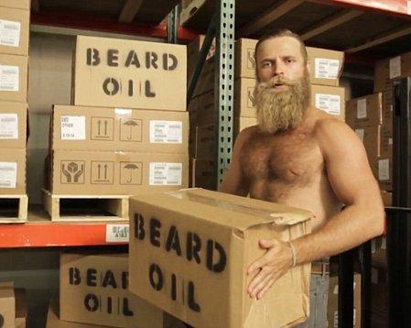

Audiences respond well to humour, particularly if it's relatable. Make your audience laugh and you'll increase the chances of your getting more eyeballs on your content.
The companies succeeding with video are the one's who aren't afraid to take risks and differentiate.

EDUCATIONAL VIDEOS
ENTERTAINING VIDEOS
Educational videos can be used to teach your audience something new or build the foundational knowledge they'll need to better understand your business and solutions. These videos can also be used by your sales and service teams as they work with customers. It's an ideal way to build trust and authority.
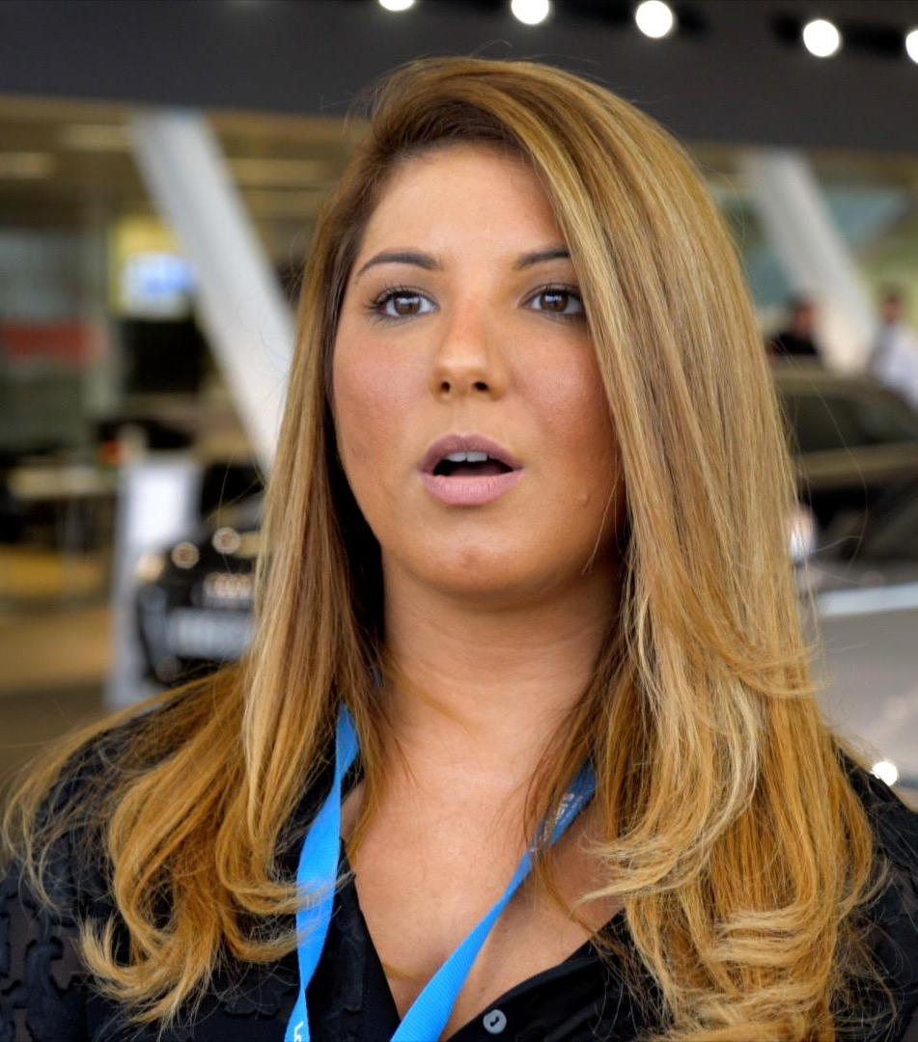
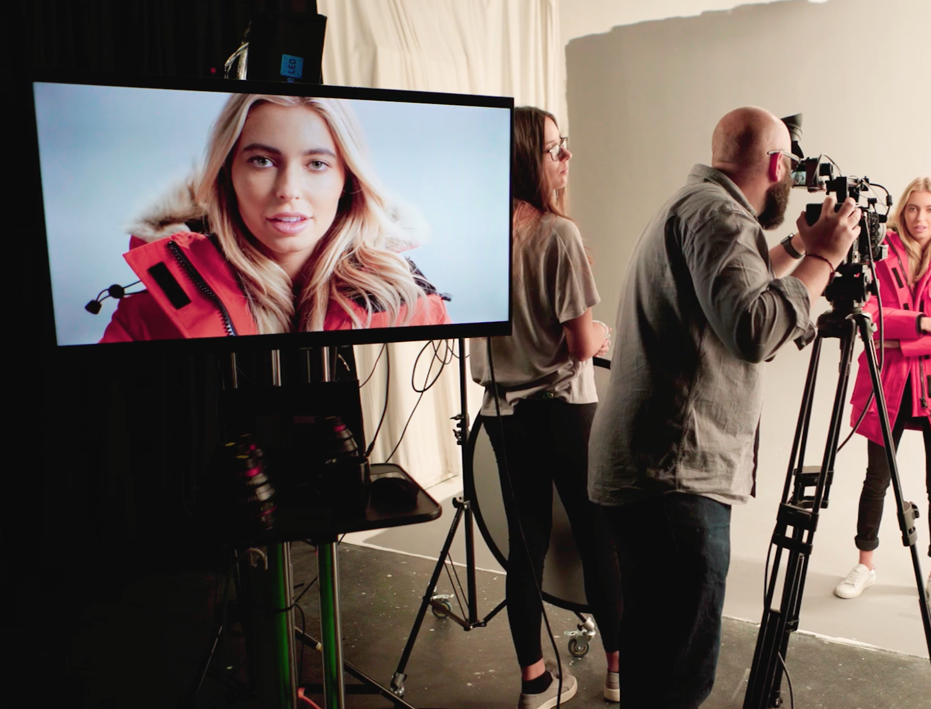
Who doesn't like getting a sneak peek into the backstage operations of your business?

It makes your audience feel included in your brand like they are receiving something exclusive which helps to build a stronger connection.
BEHIND-THE-SCENES
TESTIMONIAL VIDEOS
Where you work is great and the service or products your provide are top-notch. We don't doubt it but your customers might. Your prospects want to know that your product can (and will) solve their specific problem. One of the best ways to prove this is by creating video testimonials that feature your satisfied, loyal customers. These people are your best advocates. Get them on-camera describing their challenges and how your company helped solve them.


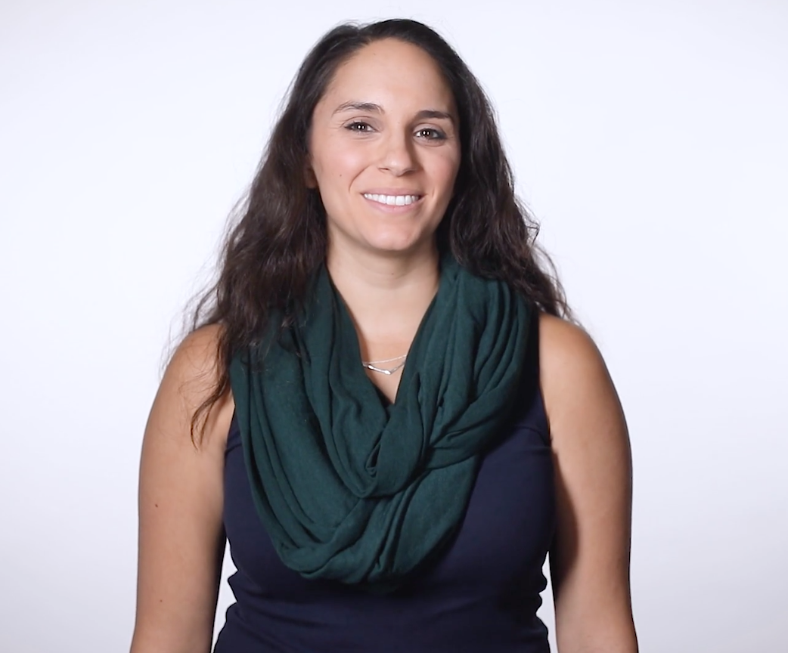
A quick video (or a series of videos) answering your most frequently asked questions can save your sales team hours not having to repeatedly answer the same questions. Plus it’s another engaging touchpoint with your customer, than scanning generic text answers to find what they need.

Is your business hosting a public event, conference, fundraiser, or another type of event?

Produce a highlight reel to show attendees who couldn't be there or use it as promotion for future events and watch attendance levels soar.
FAQ VIDEOS
This type of video is used to help your audience better understand why they need your product or service. Many explainer videos focus on a fictional journey of the company's core buyer persona who is struggling with a problem. This person overcomes the issue by adopting or buying the business's solution.
EVENT VIDEOS
EXPLAINER VIDEOS

